----------------------------------------**EKS mongodb pod backup** --------------------------------------------------

**Step1 :** got to pod login indise **kubectl exec -it mongodb-pod bash** (or)  
 **kubectl exec -it mongodb-pod -- bash** (or) **kubectl exec -it mongodb-pod -- /bin/bash** and login to shell mongodb **mongosh**

**In my case using minikube got the last page doc perquisites to setup it**

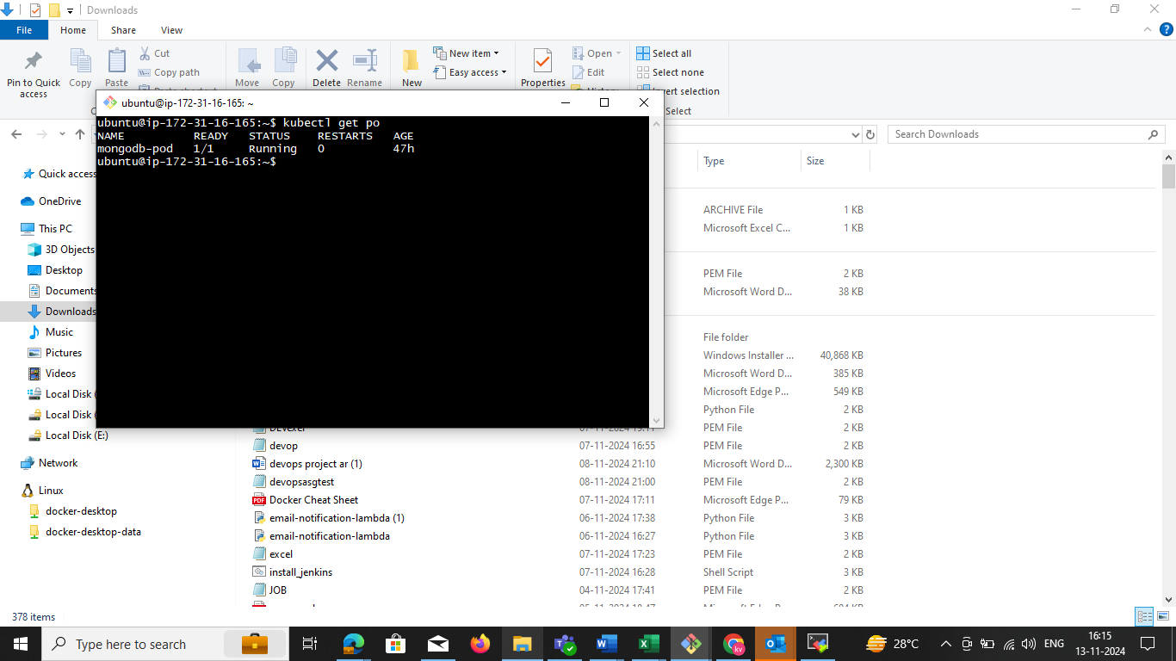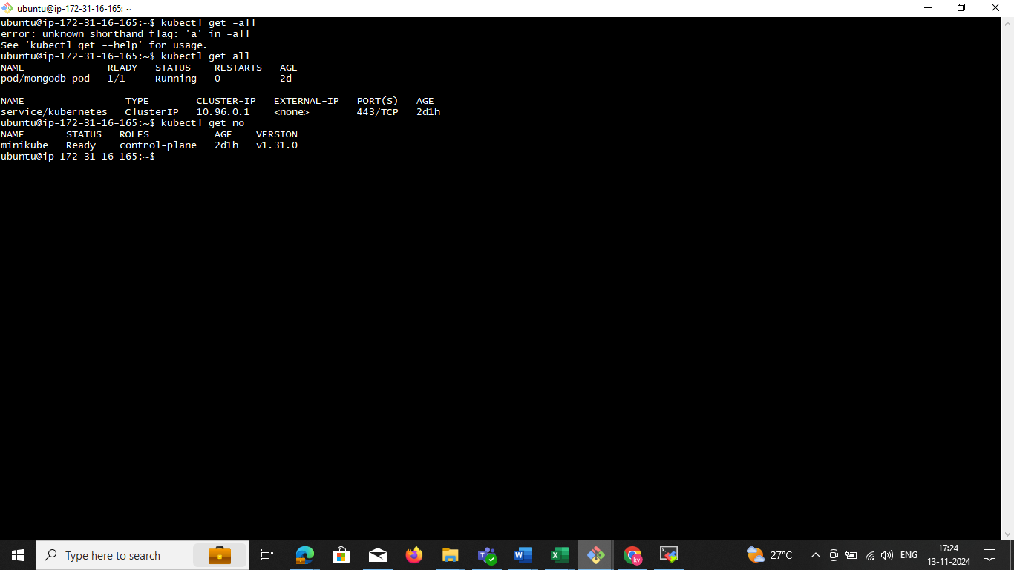

Now we need to enter in to the inside pod

Fallow **step1** command now you enter inside of the pod then **mongosh**

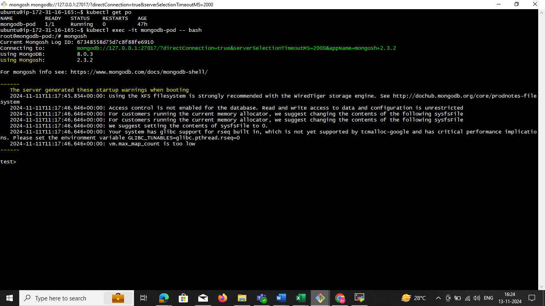

**Step2:** create user 🡪 **use sss** now you can switch in to ssc

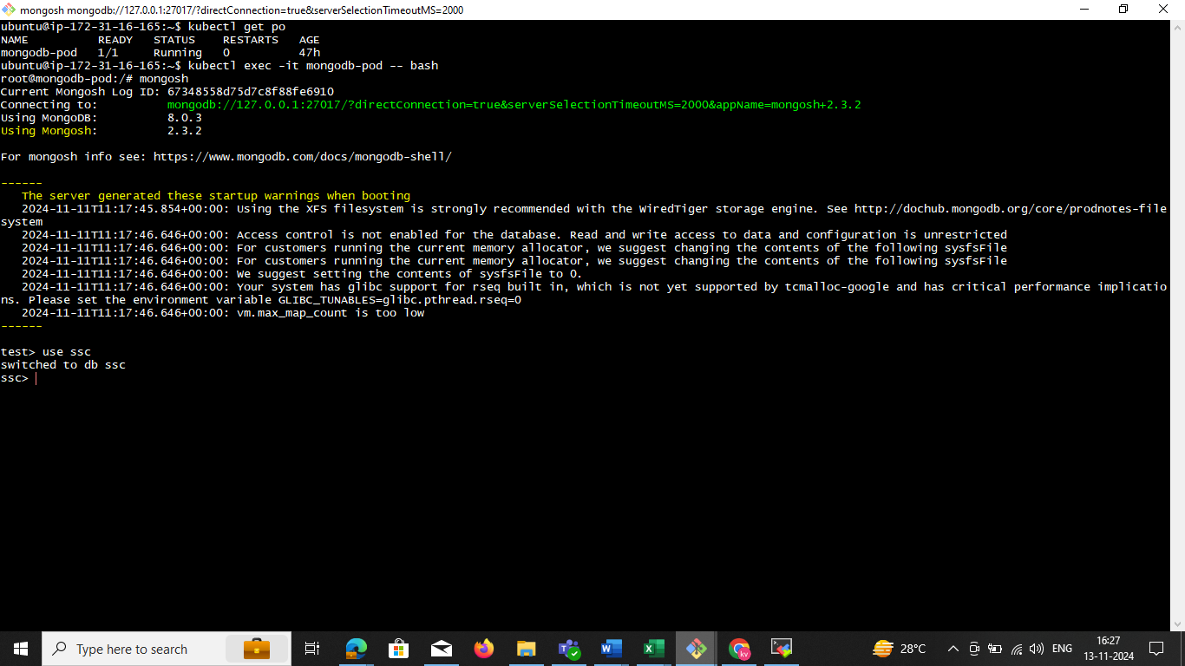

**Step3:** create the collection **db.createCollection("ssc")**

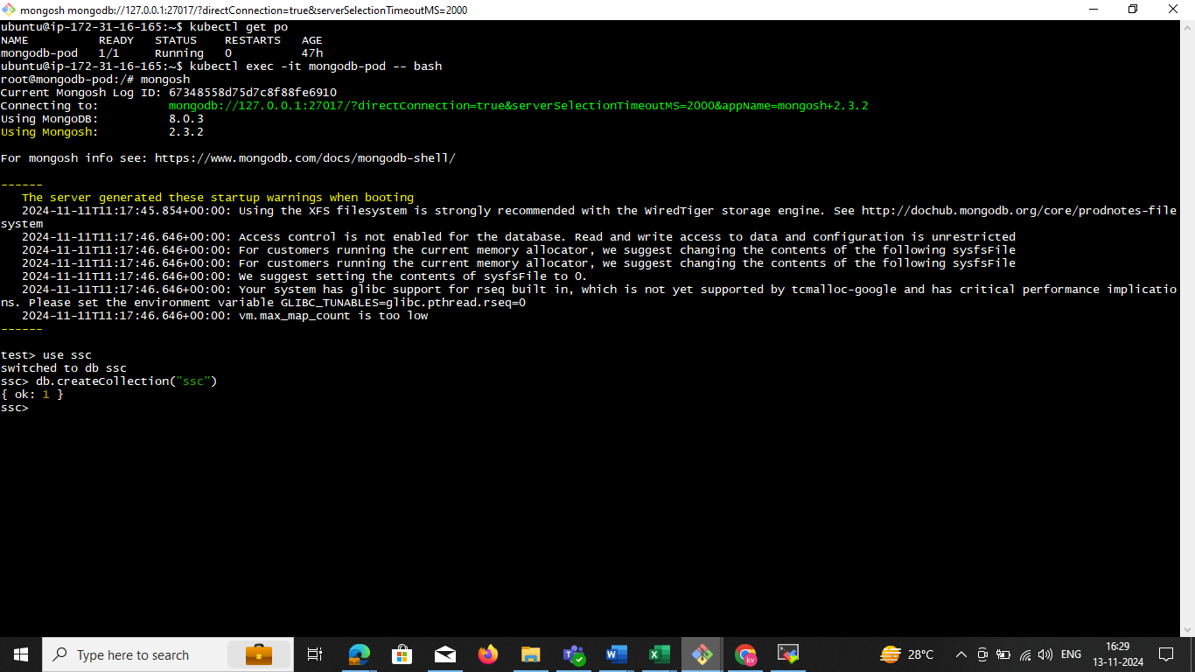

**Step4:** Insert Multiple Documents and collection

db.mycollection.insertMany([

{ name: "Bob", age: 30, city: "Chicago" },

{ name: "Charlie", age: 28, city: "San Francisco" }

]) collection name

db. **ssc**.insertMany([

{ name: "Bob", age: 30, city: "Chicago" },

{ name: "pod", age: 29, city: "San Francisco" }

])

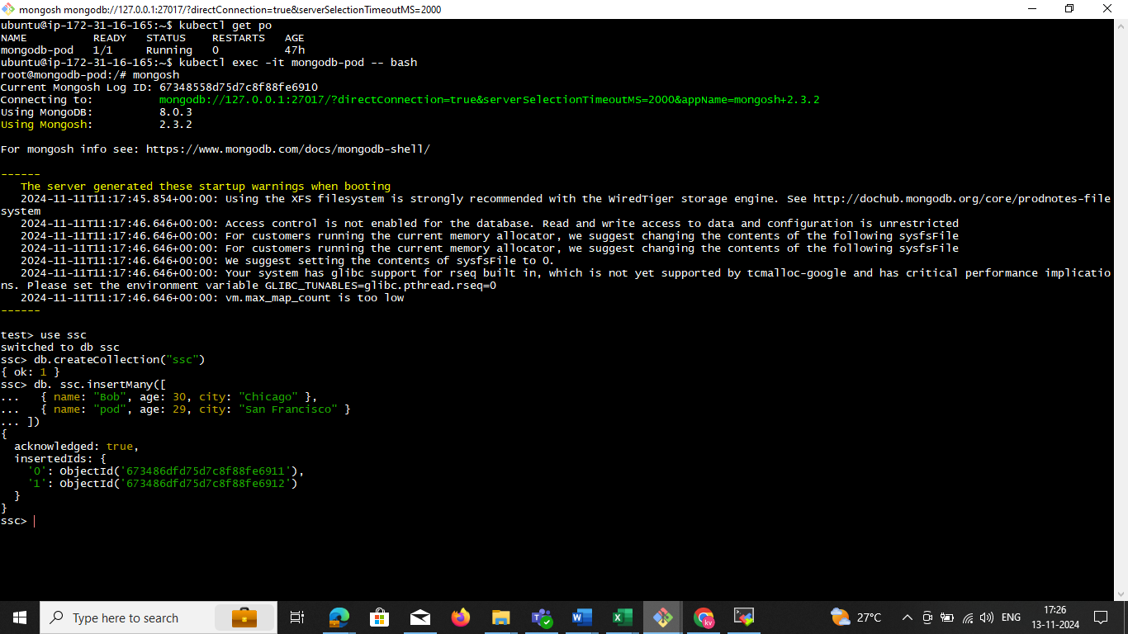

**Step5**: use this command single DB and Multiple db

kubectl exec -it mongodb-pod -- mongodump --db **mgdata** --out /home/ubuntu/**devopd**/

kubectl cp mongodb-pod:/home/ubuntu**/ags/** /home/ubuntu**/ags/**

ls -la /home/ubuntu**/uat/**

**Multiple db**

kubectl exec -it **mongodb-pod** -- mongodump --out /home/ubuntu/**allbackup**/

kubectl cp mongodb-pod:/home/ubuntu/**allbackup**/ /home/ubuntu/**allbackup**/

ls -la /home/ubuntu**/allbackup/**

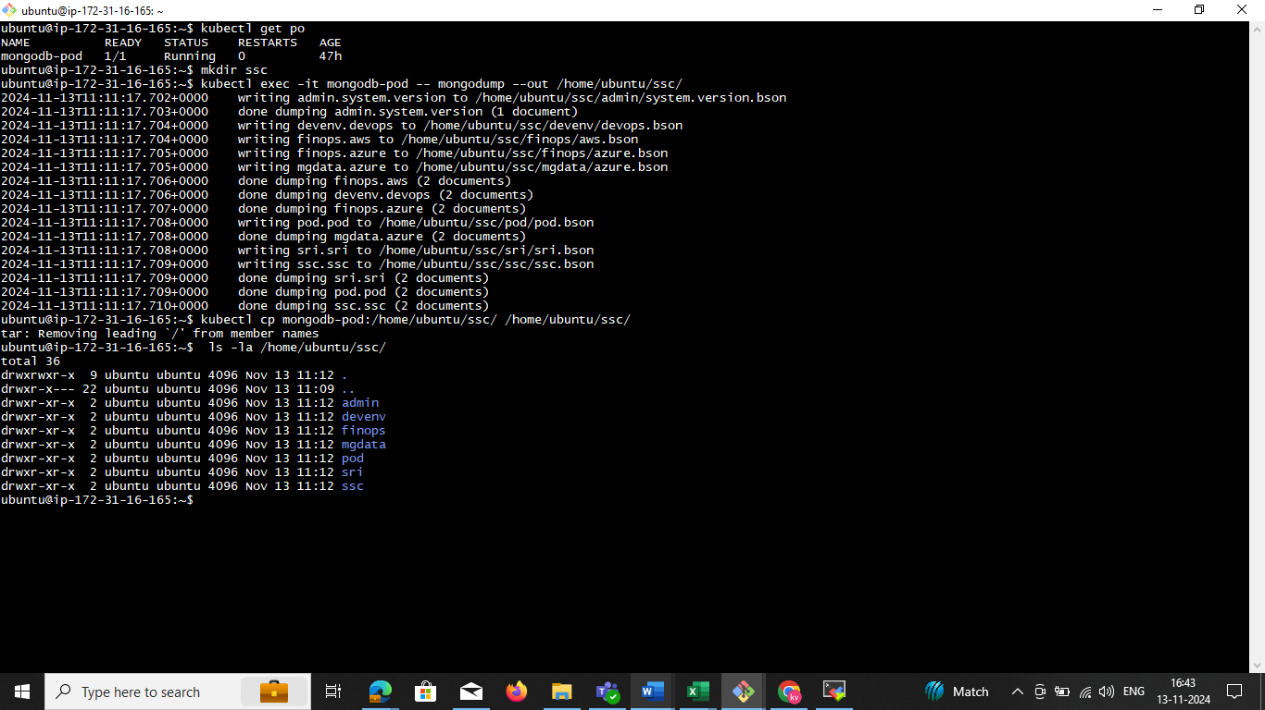

**step6 : scp**

scp -i "minikub.pem" -r ubuntu@ec2-52-207-148-195.compute-1.amazonaws.com:/home/ubuntu/ssc/ "/c/Users/TS/3D Objects/"

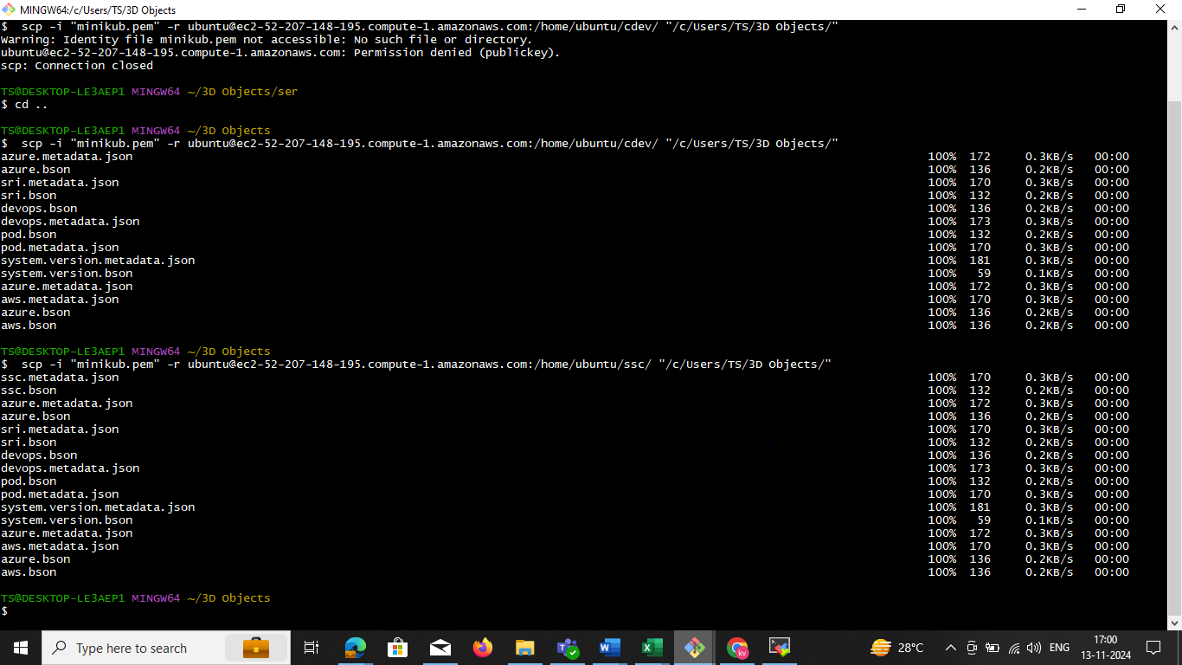

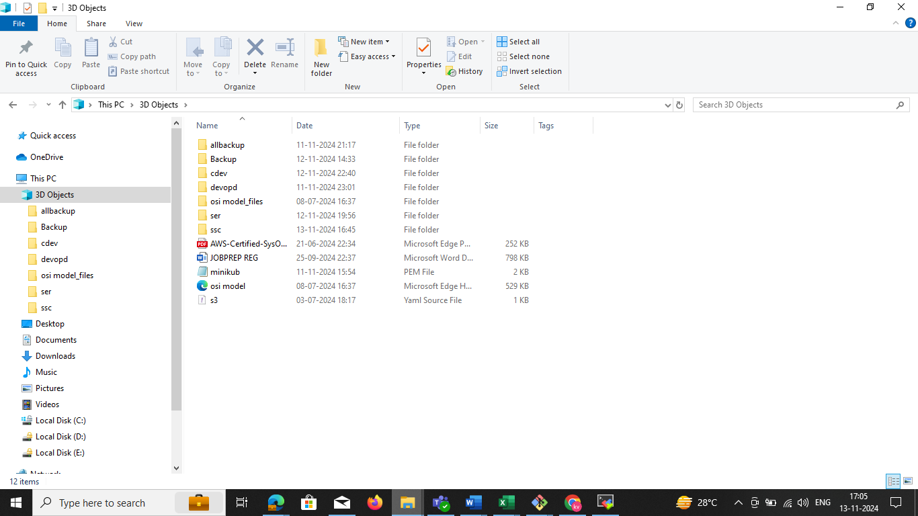**step7:** nowwe need to check the local windows system

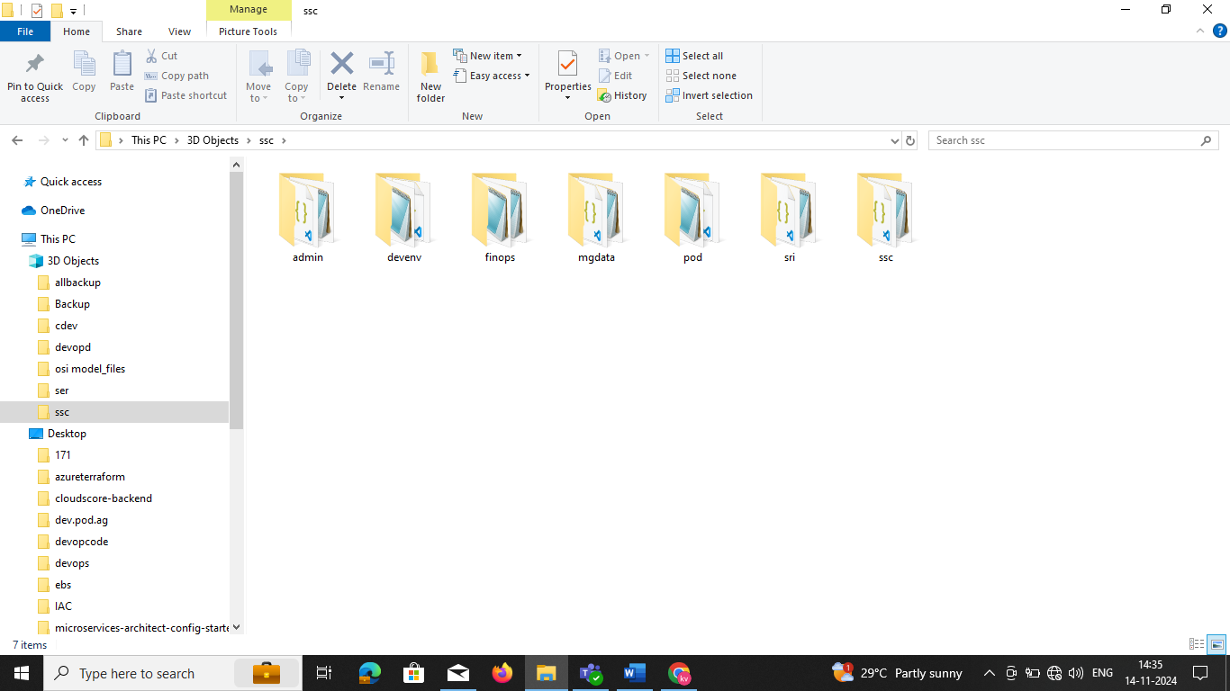

**----------------------------------------------prerequisites---------------------------------------------------------**

To install Minikube on Ubuntu, you need the following minimum requirements:

* **CPU**: At least two CPUs

* **Memory**: 2 GB of free memory

* **Disk space**: 20 GB of free disk space

* **Internet connection**: An internet connection

* **Container or virtual machine manager**: A container or virtual machine manager, such as Docker, QEMU, Hyperkit, Hyper-V, KVM, Parallels, Podman, VirtualBox, or VMware Fusion/Workstation

* **User**: A user with sudo privileges

Minikube is a tool that runs a single-node Kubernetes cluster inside a virtual machine (VM) on your laptop. It's useful for people who want to try Kubernetes or develop with it on a day-to-day basis

**Install steps in below minikube**

sudo apt-get update -y

sudo apt-get install apt-transport-https ca-certificates curl gnupg-agent software-properties-common -y

curl -fsSL https://download.docker.com/linux/ubuntu/gpg | sudo apt-key add -

sudo add-apt-repository "deb [arch=amd64] https://download.docker.com/linux/ubuntu $(lsb_release -cs) stable"

sudo apt-get update -y

sudo apt-get install docker-ce docker-ce-cli containerd.io -y

curl -LO https://storage.googleapis.com/kubernetes-release/release/`curl -s https://storage.googleapis.com/kubernetes-release/release/stable.txt`/bin/linux/amd64/kubectl

chmod +x ./kubectl

sudo mv ./kubectl /usr/local/bin/kubectl

curl -LO https://storage.googleapis.com/minikube/releases/latest/minikube-linux-amd64

sudo install minikube-linux-amd64 /usr/local/bin/minikube

####

echo the script is now ready

echo manually run minikube start --vm-driver=docker --cni=calico to start minikube

sudo usermod -aG docker $USER

newgrp docker

minikube start --vm-driver=docker --cni=calico

**CREATE the pod**

apiVersion: v1

kind: Pod

metadata:

name: mongodb-pod

labels:

app: mongodb

spec:

containers:

- name: mongodb

image: mongo:latest

ports:

- containerPort: 27017

volumeMounts:

- name: mongodb-storage

mountPath: /data/db

volumes:

- name: mongodb-storage

emptyDir: {}

vi mongodb-pod.yaml

kubectl apply -f mongodb-pod.yaml

kubectl get pods

**Step 1: Back Up All Databases**

You can use mongodump to create a backup of all MongoDB databases. This command can be run from within the Kubernetes Pod.

1. **Create a Backup Directory**: First, create a directory on your local machine where you want to store the backup:

mkdir /path/to/backup

1. **Run mongodump Inside the MongoDB Pod**: Run the following command to create a backup of all databases:

kubectl exec -it mongodb-pod -- mongodump --out /tmp/backup/

This command runs mongodump inside the mongodb-pod and dumps all databases to /tmp/backup/ in the Pod.

1. **Copy the Backup from the Pod to Local Machine**: After running the mongodump, copy the backup from the Pod to your local machine:

kubectl cp mongodb-pod:/tmp/backup/ /path/to/backup/

This command copies the backup directory from the Pod to /path/to/backup/ on your local machine.

**Step 2: Restore the Backup to a MongoDB Pod**

To restore the backup, follow these steps:

1. **Copy the Backup to the Pod**: If you have the backup on your local machine and want to restore it in the Pod, copy the backup directory back into the Pod using kubectl cp:

kubectl cp /path/to/backup/ mongodb-pod:/tmp/restore/

This command copies the backup from /path/to/backup/ on your local machine to /tmp/restore/ in the Pod.

1. **Run mongorestore Inside the Pod**: After copying the backup to the Pod, you can restore all databases by running the following command inside the Pod:

kubectl exec -it mongodb-pod -- mongorestore --dir /tmp/restore/ --drop

* + The --dir /tmp/restore/ option specifies the location of the backup.
  + The --drop option ensures that existing collections are dropped before restoring the backup.

1. **Verify the Restoration**: After restoring, you can verify that the databases have been restored by running:

kubectl exec -it mongodb-pod -- mongo --eval "show dbs"

**pritical:**

1. **Back Up All Databases:**

kubectl exec -it mongodb-pod -- mongodump --out /tmp/backup/

kubectl cp mongodb-pod:/tmp/backup/ /path/to/backup/

EXg:

kubectl cp mongodb-pod:/tmp/uat/ /home/ubuntu/sd

ubuntu@ip-172-31-16-165:~$ kubectl cp mongodb-pod:/tmp/uat/ /home/ubuntu/sd/

tar: Removing leading `/' from member names

ubuntu@ip-172-31-16-165:~$

1. **Restore All Databases:**

kubectl cp /path/to/backup/ mongodb-pod:/tmp/restore/

kubectl exec -it mongodb-pod -- mongorestore --dir /tmp/restore/ --drop

kubectl exec -it mongodb-pod -- mongorestore --dir /tmp// --drop

kubectl exec -it mongodb-pod -- mongorestore --dir /tmp/uat/ --drop

**Notes:**

* The mongodump command will back up **all databases**.
* The mongorestore command with the --drop option will overwrite existing databases.
* Ensure you have enough space on your local machine for the backup, as MongoDB backups can be large depending on the size of your databases.

drwxrwxrwt 1 root root 4096 Nov 13 13:21 ..

**root@mongodb-pod:/tmp/uat# pwd**

**/tmp/uat**

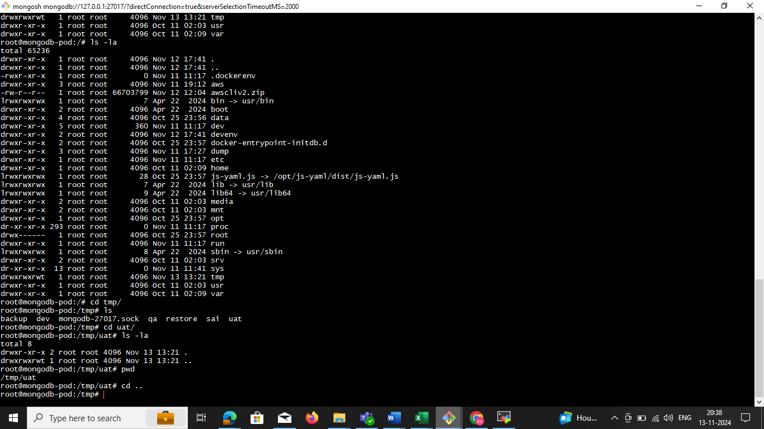

**Backup and restore**

kubectl exec -it mongodb-pod -- mongodump --out /tmp/uat/

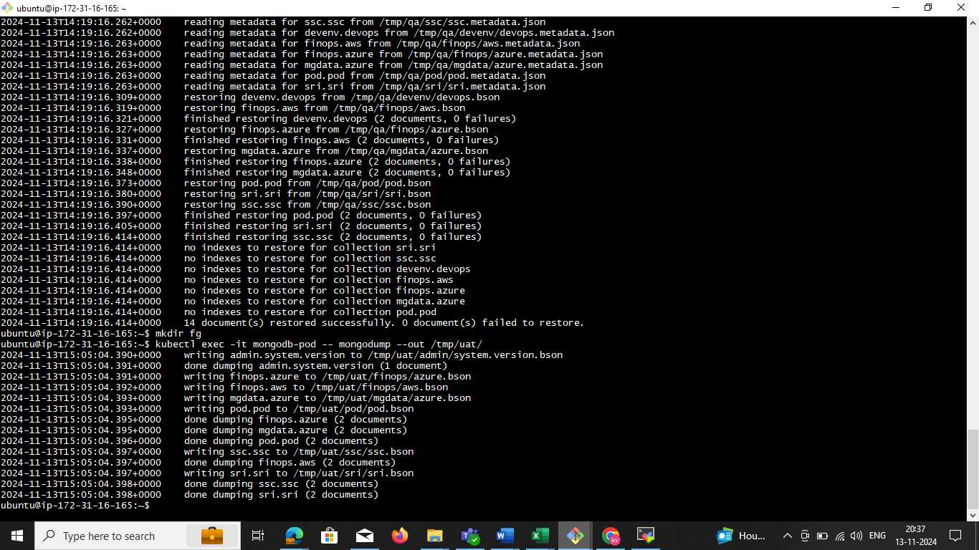

**Now we can delete the db. in the**

**use finops**

**db.dropDatabase()**

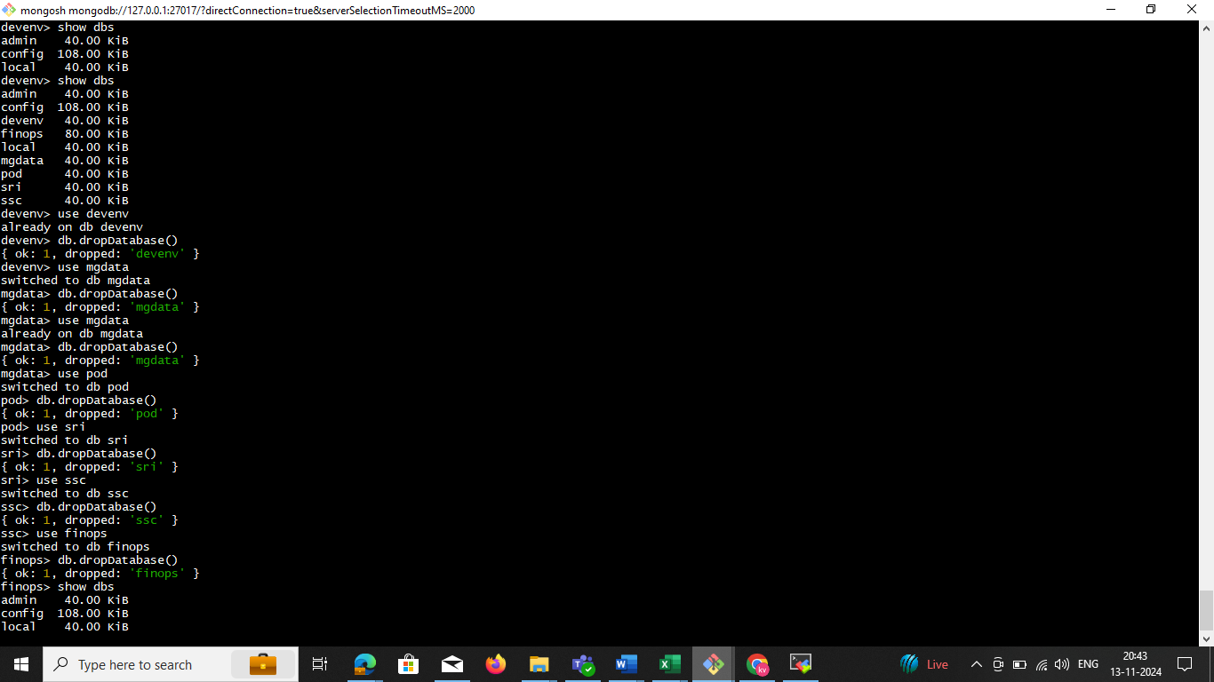

**EXg:**

**kubectl cp mongodb-pod:/tmp/uat/ /home/ubuntu/sd**

ubuntu@ip-172-31-16-165:~$ **kubectl cp mongodb-pod:/tmp/uat/ /home/ubuntu/sd/**

tar: Removing leading `/' from member names

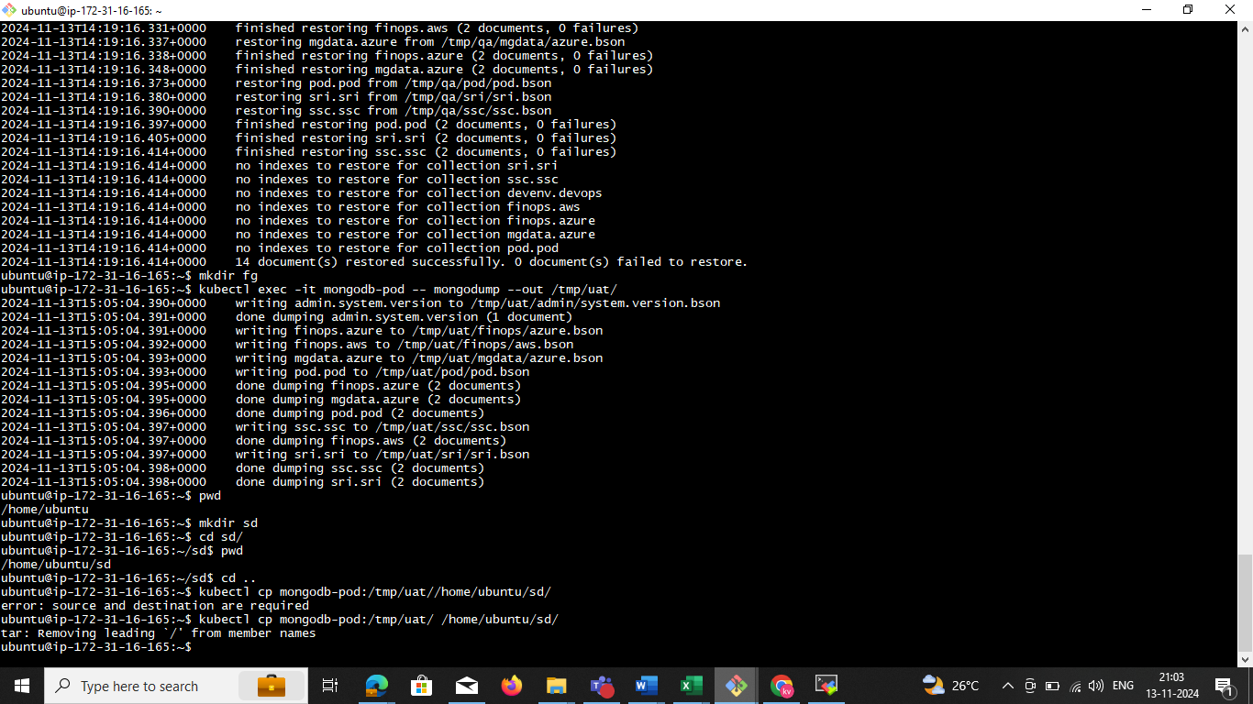

Login to **mongosh**

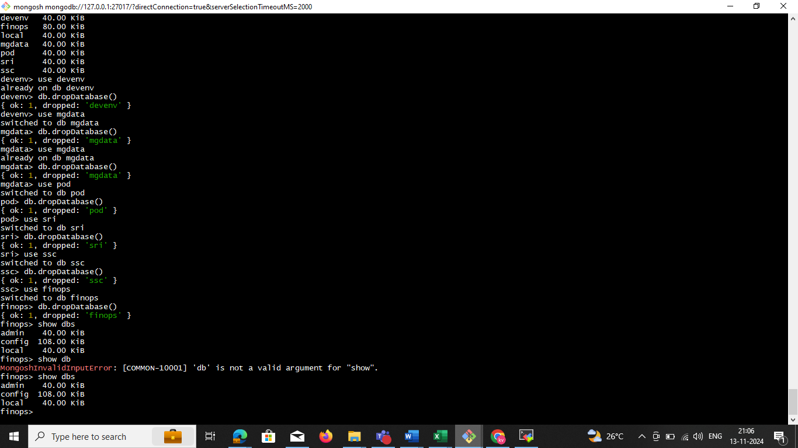

**Restore All Databases**

**kubectl exec -it mongodb-pod -- mongorestore --dir /tmp/restore/ --drop**

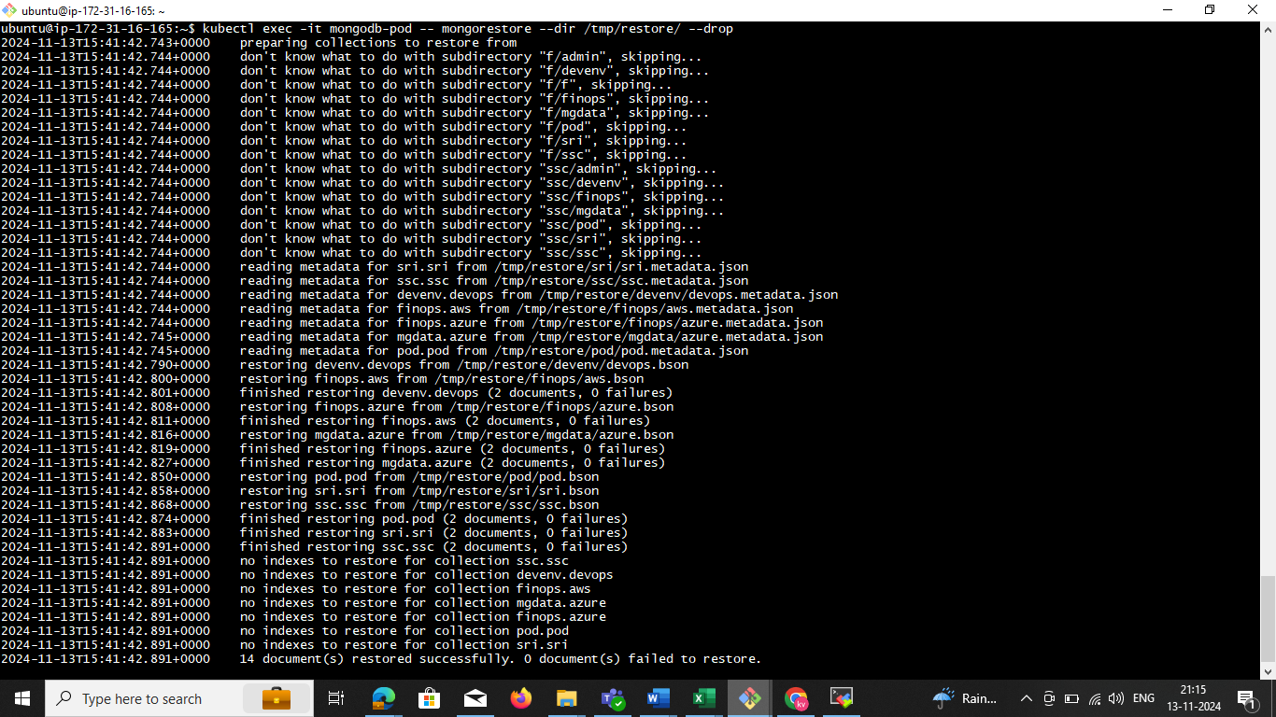

**now we need to check all db is the restore in mongo sh check it**

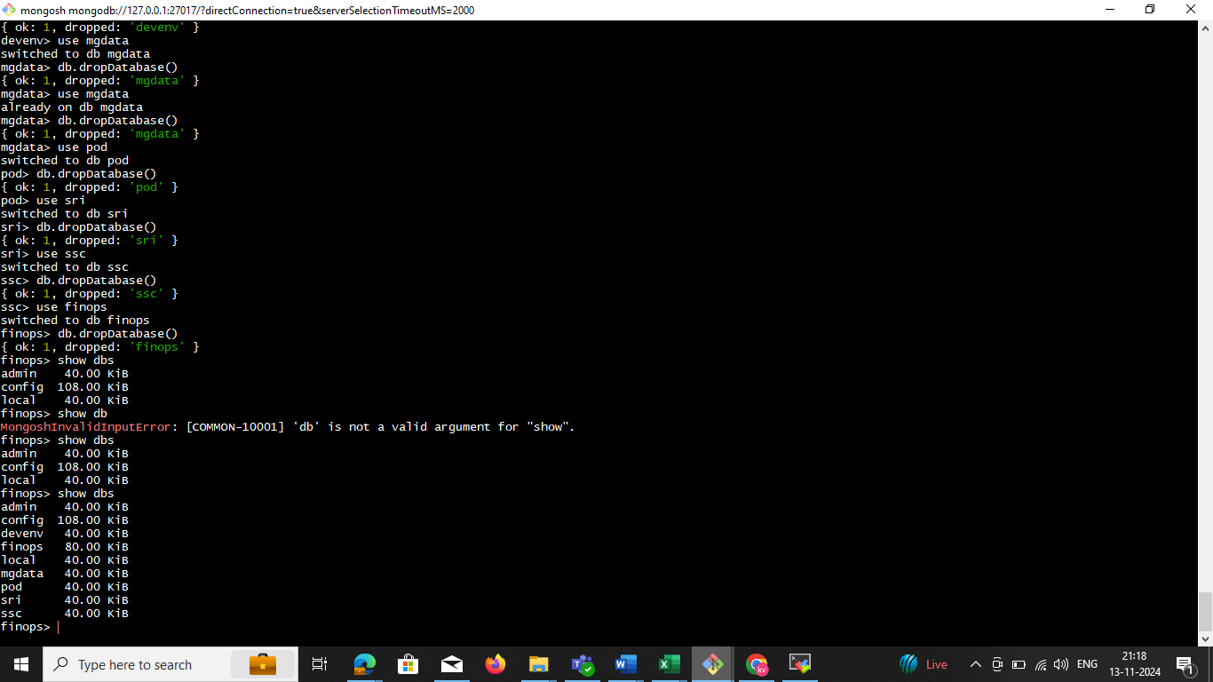

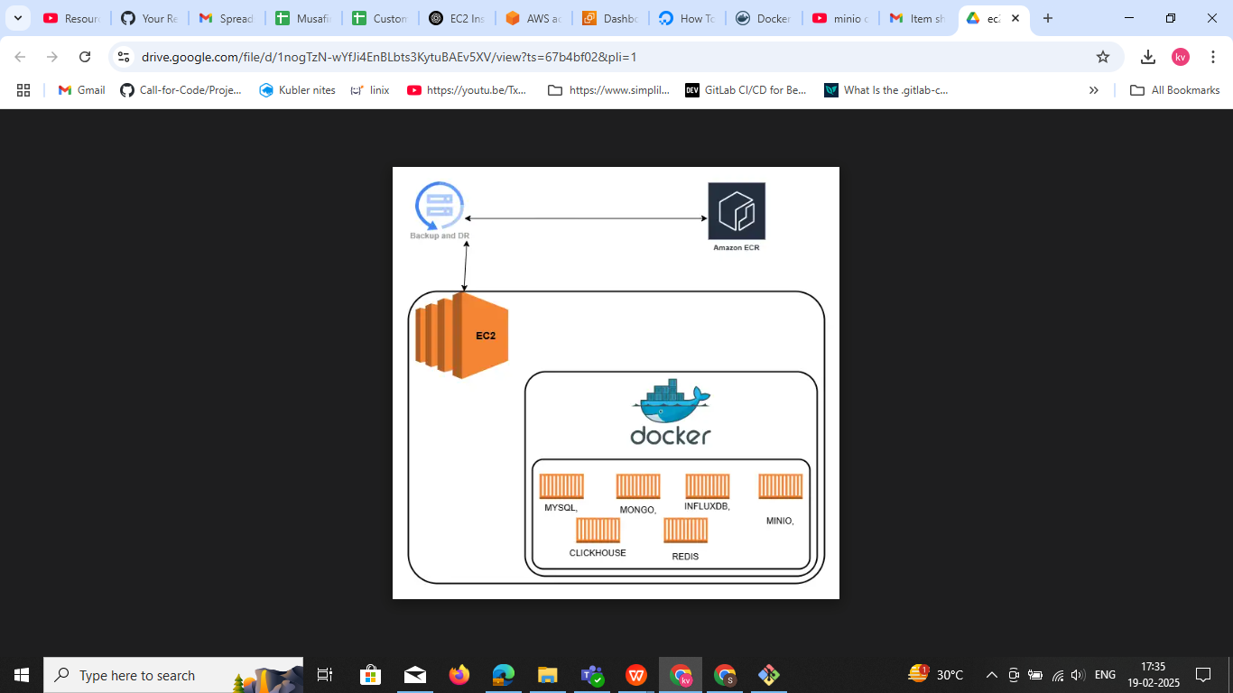

Install the all Database set up

Pervisites t3x.large

30 gb storgare

vi dockerdatabase-compose.yml

Docker file

version: '3.8'

services:

mysql:

image: mysql:latest

restart: always

environment:

MYSQL_ROOT_PASSWORD: root

MYSQL_DATABASE: mydb

MYSQL_USER: myuser

MYSQL_PASSWORD: mypassword

ports:

- "3306:3306"

mongodb:

image: mongo:latest

restart: always

environment:

MONGO_INITDB_ROOT_USERNAME: admin

MONGO_INITDB_ROOT_PASSWORD: admin

ports:

- "27017:27017"

influxdb:

image: influxdb:latest

restart: always

environment:

INFLUXDB_ADMIN_USER: admin

INFLUXDB_ADMIN_PASSWORD: admin

ports:

- "8086:8086"

minio:

image: minio/minio

restart: always

environment:

MINIO_ROOT_USER: admin

MINIO_ROOT_PASSWORD: admin123

ports:

- "9000:9000"

- "9001:9001"

command: server /data --console-address ":9001"

clickhouse:

image: clickhouse/clickhouse-server:latest

restart: always

ports:

- "8123:8123"

- "9000:9000"

redis:

image: redis:latest

restart: always

ports:

- "6379:6379"

### ****Run Docker Compose****

Since your file is not named docker-compose.yml, you must specify it using the -f flag:

**docker-compose -f dockerdatabase-compose.yml up -d**

**Explanation:**

* -f dockerdatabase-compose.yml → Specifies the file to use.
* up → Starts the services.
* -d → Runs in **detached mode** (in the background).

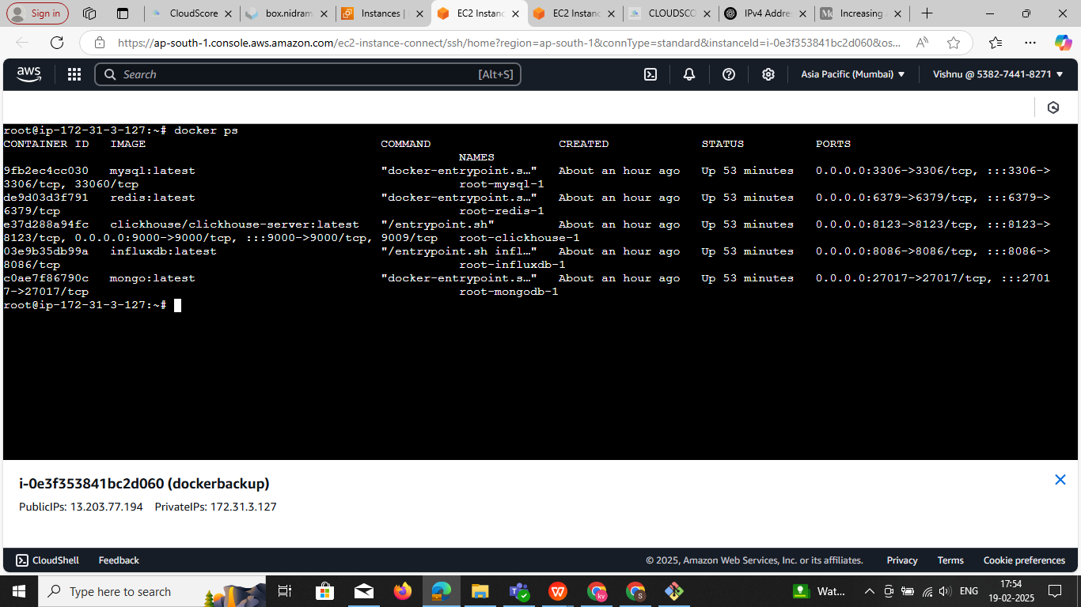

Login the mysql

**docker exec -it root-mysql-1 mysql -u root -p**

**docker exec -it root-mysql-1 mysql -u root**

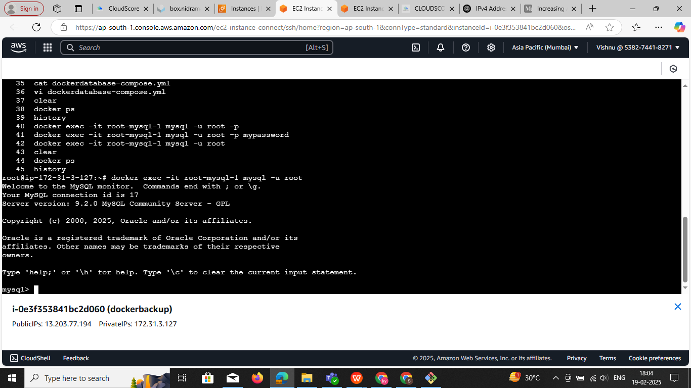

docker exec -it root-redis-1 redis-cli

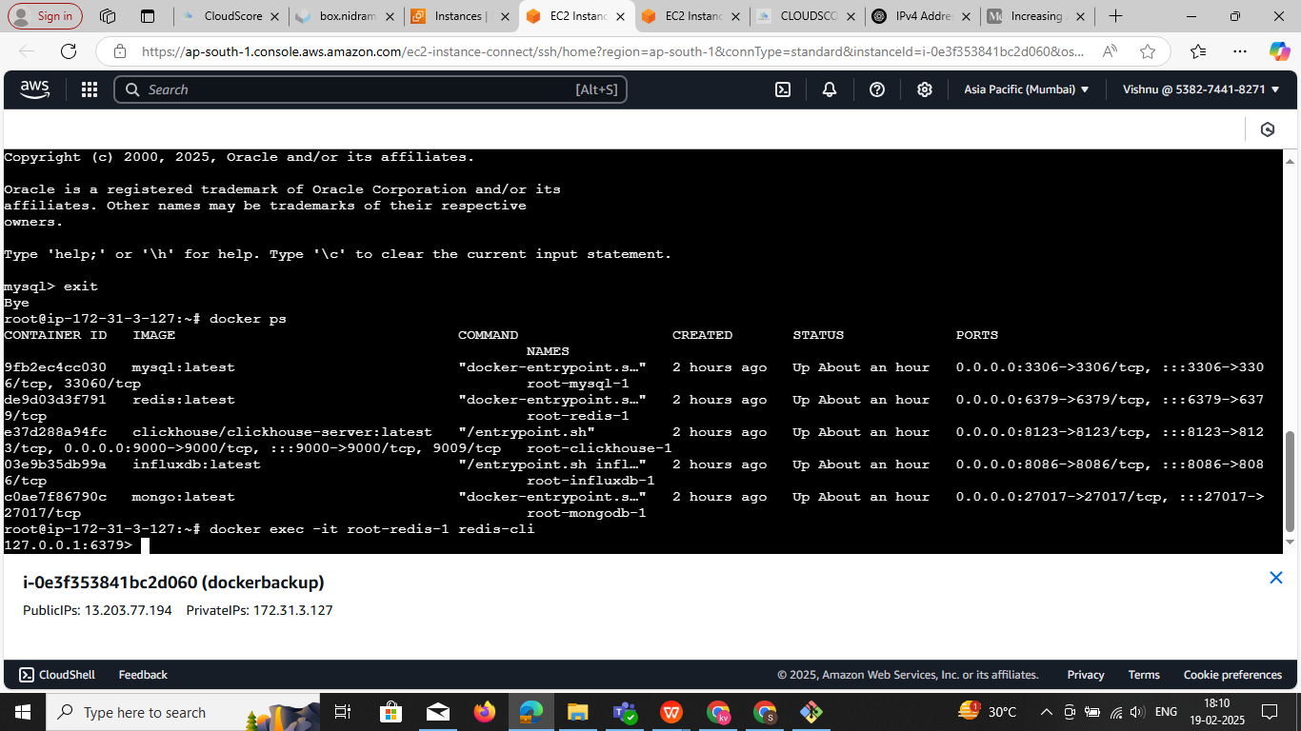

**root@ip-172-31-3-127:~# docker exec -it root-clickhouse-1 clickhouse-client --host localhost**

ClickHouse client version 25.1.4.53 (official build).

Connecting to localhost:9000 as user default.

Connected to ClickHouse server version 25.1.4.

Warnings:

* Delay accounting is not enabled, OSIOWaitMicroseconds will not be gathered. You can enable it using `echo 1 > /proc/sys/kernel/task_delayacct` or by using sysctl.

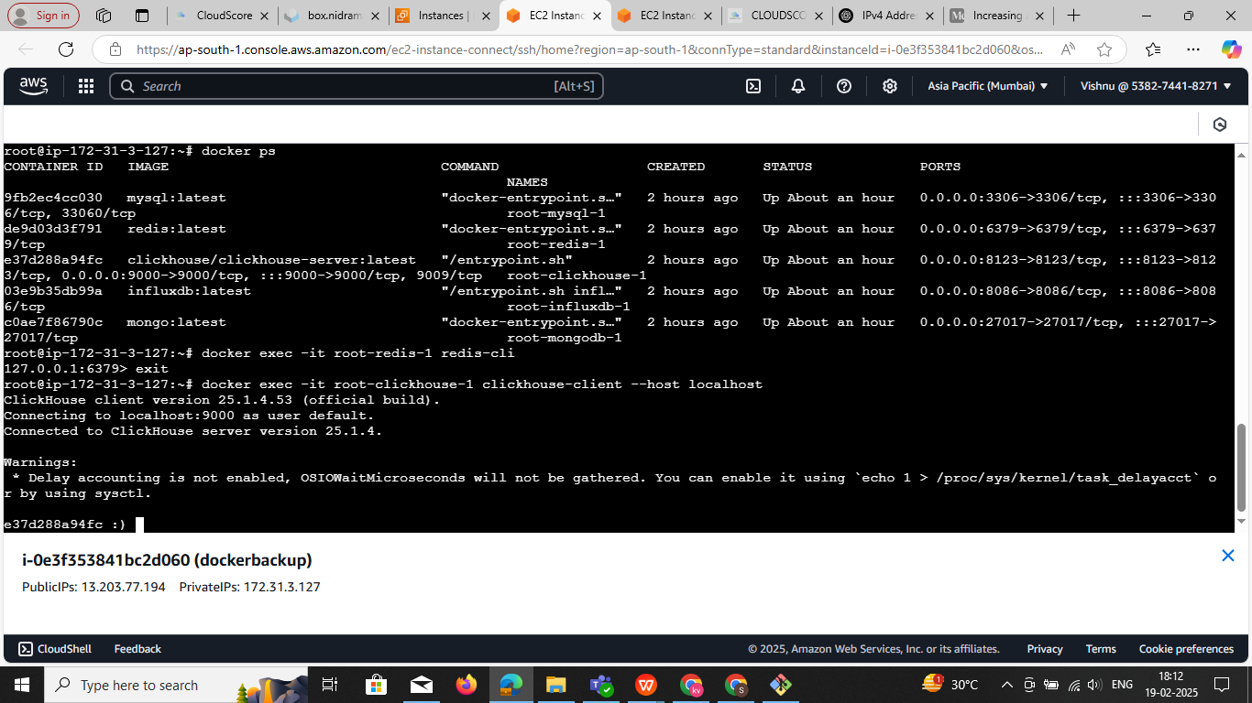

### ****Access the Container Shell****

Use the docker exec command to start an interactive shell inside the container:

docker exec -it root-influxdb-1 /bin/bash

To **remove all containers (running & stopped) and images** in a single command, run:

docker rm -f $(docker ps -aq) && docker rmi -f $(docker images -aq)

### Explanation:

* docker ps -aq → Lists all container IDs.
* docker rm -f $(docker ps -aq) → Force removes all containers.
* docker images -aq → Lists all image IDs.
* docker rmi -f $(docker images -aq) → Force removes all images.

⚠️ **Warning:** This will completely clean up **all containers and images** on your system.  
If you also want to remove unused volumes and networks, use:

docker system prune -a -f

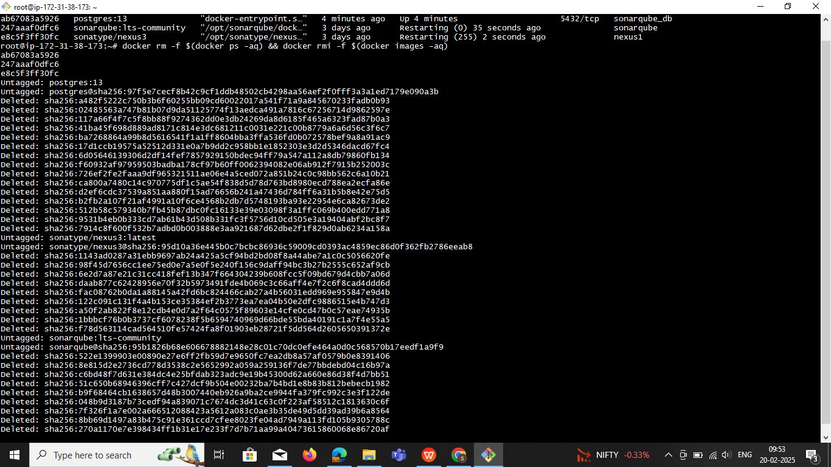

**mongodb**

docker exec -it root-mongodb-1 mongosh -u admin -p admin

show dbs;

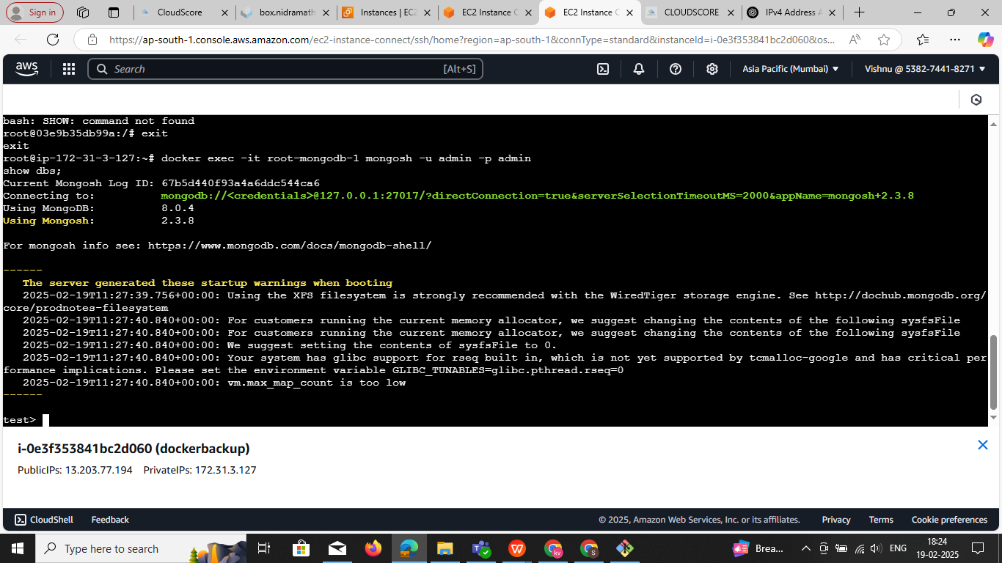

**DataBase: clickhouse**

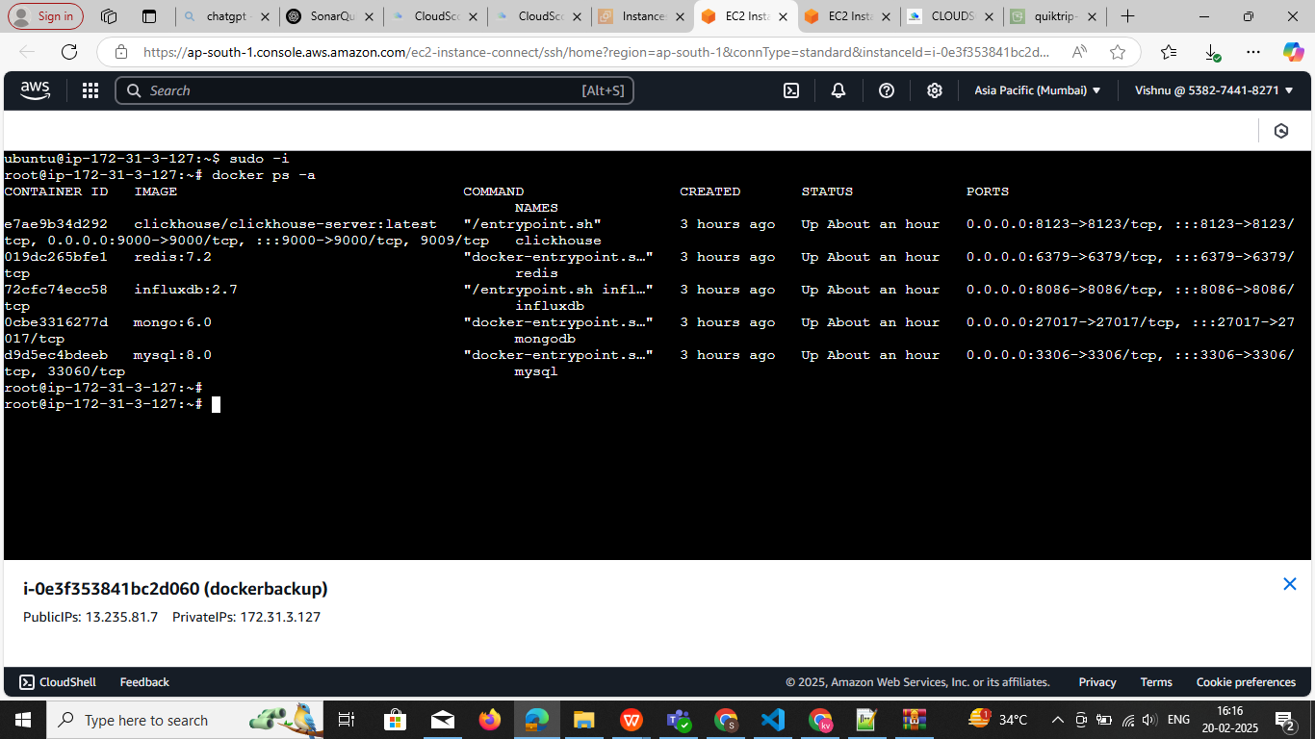

**Command to login** :**docker exec -it clickhouse clickhouse-client**

1. Ensure a Table Exists

Before inserting data, create a table that matches your dataset:

CREATE TABLE cloud_resources (

cloud_resource_id String,

resource_name String,

resource_id String,

cloud_account_id String,

cloud_type String,

region String,

flavor String,

saving Float64,

average_saving Float64

) ENGINE = MergeTree()

ORDER BY cloud_resource_id;

**2. Insert Data Manually**

You can insert records one by one:

**INSERT INTO cloud_resources VALUES**

**('i-0e6e93115558486f1', 'MUAP-WEB01', '045626cf-beb2-4fea-8345-37e2d4131fd0', 'fcc6f5d1-f5a7-494e-b8b9-99a47130ef12', 'aws_cnr', 'ap-south-1', 'c5.4xlarge', 149.1866667, 46.08),**

**('i-0ff1655eab984d3da', 'MUAP-B2BAPI01', '13e94cd4-bb44-4ef4-8dee-e9884bcdbb54', 'fcc6f5d1-f5a7-494e-b8b9-99a47130ef12', 'aws_cnr', 'ap-south-1', 'r5.2xlarge', 109.7766667, 57.6);**

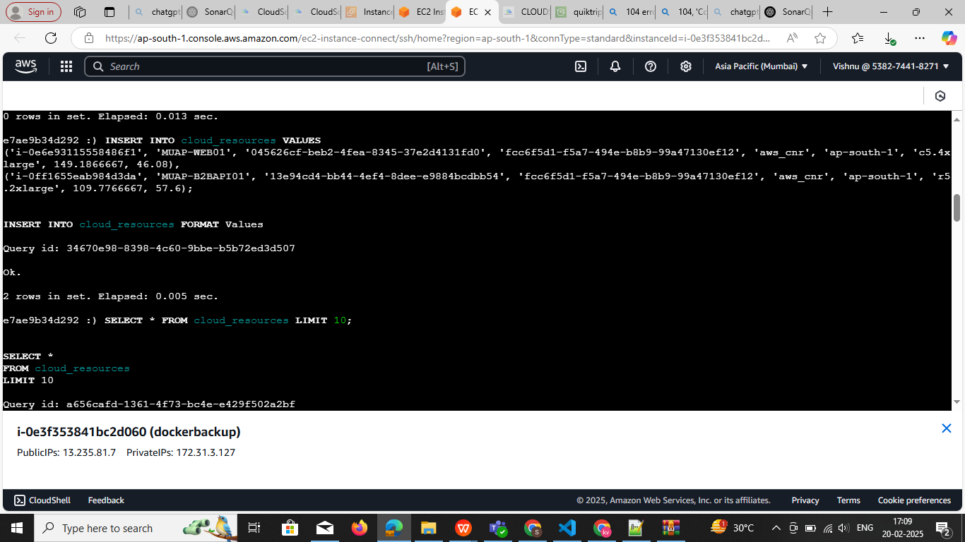

**3. Bulk Insert from a File (Recommended)**

**Step 1:** Save Data as a CSV File

Create a CSV file (data.csv) with this format:

cloud_resource_id,resource_name,resource_id,cloud_account_id,cloud_type,region,flavor,saving,average_saving

i-0e6e93115558486f1,MUAP-WEB01,045626cf-beb2-4fea-8345-37e2d4131fd0,fcc6f5d1-f5a7-494e-b8b9-99a47130ef12,aws_cnr,ap-south-1,c5.4xlarge,149.1866667,46.08

i-0ff1655eab984d3da,MUAP-B2BAPI01,13e94cd4-bb44-4ef4-8dee-e9884bcdbb54,fcc6f5d1-f5a7-494e-b8b9-99a47130ef12,aws_cnr,ap-south-1,r5.2xlarge,109.7766667,57.6

...

**Step 2:** Copy the File into the ClickHouse Container

If data.csv is on your local machine, copy it into the running container:

**docker cp data.csv clickhouse:/data.csv**

**Step 3:** Load Data into ClickHouse

Now, run this inside the ClickHouse client:

INSERT INTO cloud_resources FORMAT CSV

docker exec -i clickhouse clickhouse-client --query="INSERT INTO cloud_resources FORMAT CSV" < data.csv

**4. Verify Data**

To confirm data was inserted correctly:

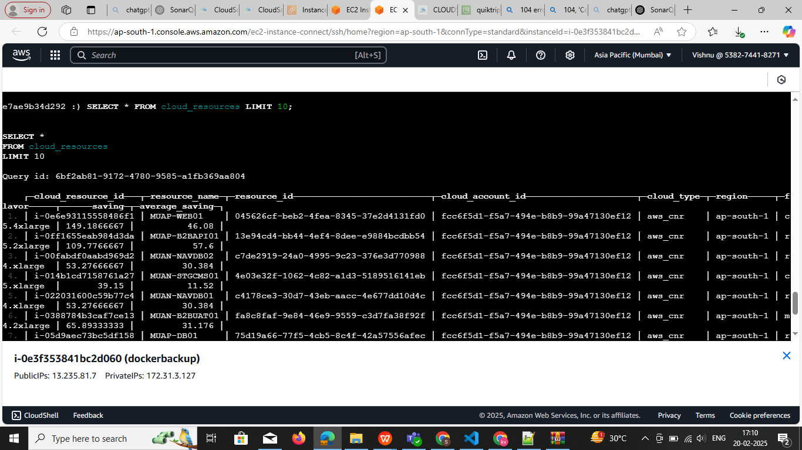**SELECT * FROM cloud_resources LIMIT 10;**

**Redis-ci**

## **Login to Redis Container** Run the following command to enter the Redis CLI:

## docker exec -it redis redis-cli and insert data

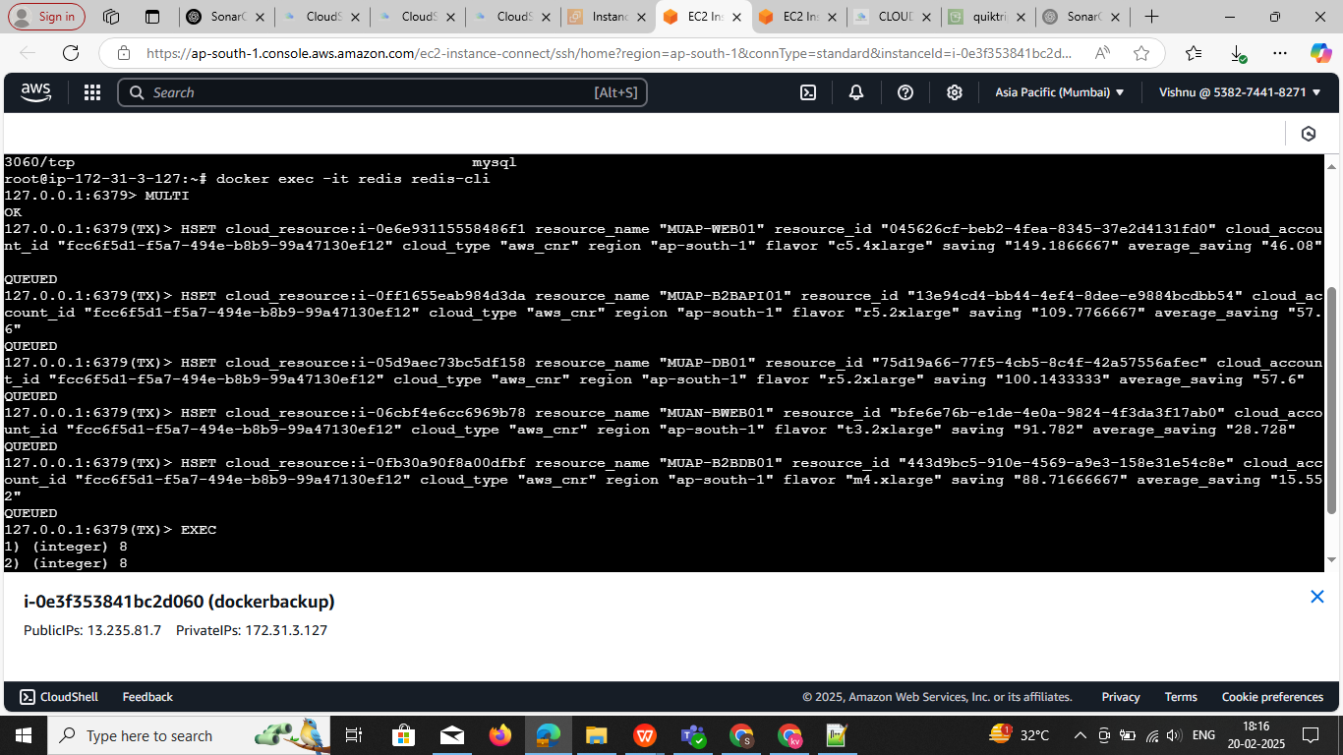

## ****Use a Redis Pipeline to Insert Multiple Records****

## Copy and paste the following into the Redis CLI to insert all data in **bulk**:

**MULTI**

HSET cloud_resource:i-0e6e93115558486f1 resource_name "MUAP-WEB01" resource_id "045626cf-beb2-4fea-8345-37e2d4131fd0" cloud_account_id "fcc6f5d1-f5a7-494e-b8b9-99a47130ef12" cloud_type "aws_cnr" region "ap-south-1" flavor "c5.4xlarge" saving "149.1866667" average_saving "46.08"

HSET cloud_resource:i-0ff1655eab984d3da resource_name "MUAP-B2BAPI01" resource_id "13e94cd4-bb44-4ef4-8dee-e9884bcdbb54" cloud_account_id "fcc6f5d1-f5a7-494e-b8b9-99a47130ef12" cloud_type "aws_cnr" region "ap-south-1" flavor "r5.2xlarge" saving "109.7766667" average_saving "57.6"

HSET cloud_resource:i-05d9aec73bc5df158 resource_name "MUAP-DB01" resource_id "75d19a66-77f5-4cb5-8c4f-42a57556afec" cloud_account_id "fcc6f5d1-f5a7-494e-b8b9-99a47130ef12" cloud_type "aws_cnr" region "ap-south-1" flavor "r5.2xlarge" saving "100.1433333" average_saving "57.6"

HSET cloud_resource:i-06cbf4e6cc6969b78 resource_name "MUAN-BWEB01" resource_id "bfe6e76b-e1de-4e0a-9824-4f3da3f17ab0" cloud_account_id "fcc6f5d1-f5a7-494e-b8b9-99a47130ef12" cloud_type "aws_cnr" region "ap-south-1" flavor "t3.2xlarge" saving "91.782" average_saving "28.728"

HSET cloud_resource:i-0fb30a90f8a00dfbf resource_name "MUAP-B2BDB01" resource_id "443d9bc5-910e-4569-a9e3-158e31e54c8e" cloud_account_id "fcc6f5d1-f5a7-494e-b8b9-99a47130ef12" cloud_type "aws_cnr" region "ap-south-1" flavor "m4.xlarge" saving "88.71666667" average_saving "15.552"

EXEC

## ****3 Verify Data in Redis****

To check if the data was inserted correctly, run:

HGETALL cloud_resource:**i-0e6e93115558486f1 change ids**

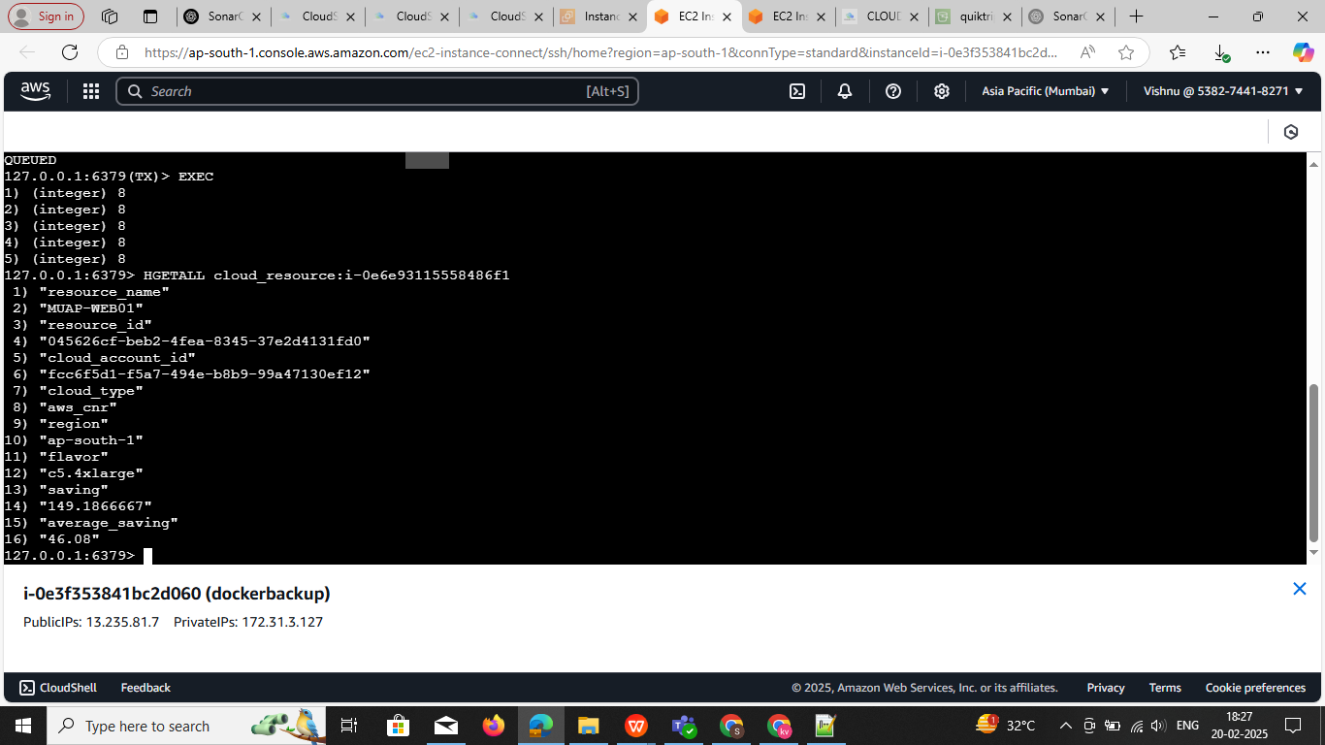

## ****Verify Data in Redis****

To check if the data was inserted correctly, run:

redis

CopyEdit

HGETALL cloud_resource:i-0e6e93115558486f1

✔️ **Output:**

arduino

CopyEdit

1) "resource_name"2) "MUAP-WEB01"3) "resource_id"4) "045626cf-beb2-4fea-8345-37e2d4131fd0"5) "cloud_account_id"6) "fcc6f5d1-f5a7-494e-b8b9-99a47130ef12"7) "cloud_type"8) "aws_cnr"9) "region"10) "ap-south-1"11) "flavor"12) "c5.4xlarge"13) "saving"14) "149.1866667"15) "average_saving"16) "46.08"

## ****Bonus:Import Data from a CSV File into Redis****

If you have a **CSV file** with your data, you can use a Python script to import it into Redis.

### ****1Create**** data.csv

csv

CopyEdit

cloud_resource_id,resource_name,resource_id,cloud_account_id,cloud_type,region,flavor,saving,average_saving

i-0e6e93115558486f1,MUAP-WEB01,045626cf-beb2-4fea-8345-37e2d4131fd0,fcc6f5d1-f5a7-494e-b8b9-99a47130ef12,aws_cnr,ap-south-1,c5.4xlarge,149.1866667,46.08

i-0ff1655eab984d3da,MUAP-B2BAPI01,13e94cd4-bb44-4ef4-8dee-e9884bcdbb54,fcc6f5d1-f5a7-494e-b8b9-99a47130ef12,aws_cnr,ap-south-1,r5.2xlarge,109.7766667,57.6

### ****2️⃣ Run a Python Script to Import****

python

CopyEdit

import csvimport redis

# Connect to Redis

r = redis.Redis(host='localhost', port=6379, decode_responses=True)

# Open CSV filewith open('data.csv', 'r') as file:

reader = csv.DictReader(file)

for row in reader:

key = f"cloud_resource:{row['cloud_resource_id']}"

r.hset(key, mapping=row)

print("Data imported successfully!")